IMPLEMENTATION OF 15th JDC PUBLIC DEFENDER’S OFFICE DATABASE

By

Erwin Kristel, Charaf Lachouri and Patrick Cardozo

**Contribution Breakdown**

Erwin Kristel: Worked on Normalization, SQL Statements, Demo, Testing of Attorney and District records. Edited ER Diagram, Abstracts, mission statement, mission objectives and did part of use case.

Charaf Lachouri: Worked on ER Diagram, SQL Statement, Testing of Prosecutor and Client Records, Conclusion

Patrick Cardozo: Worked on Abstract, Mission Statement, Mission Objectives, Use Case, Database Functionalities, Testing of Court date and Criminal case record, contribution.

**References**

* Erwin Kristel – experience as a public defender in the 15th JDC PDO
* 15th Judicial District Public Defenders Office of Louisiana, 15jdpdo.org
* District Attorney for the 15th Judicial Court, <https://districtattorney15thjdc.org/>
* 15th Judicial District Court Acadia, Lafayette, & Vermilion Parishises, Louisiana, https://www.15thjdc.org/

**Abstract**

We plan to develop a database for the 15th JDC Public Defender's Office (PDO), who is interested in a database aid their attorneys in tracking case information. It should be easy for attorneys to view and update case data and client information. For any instance of a case, only the attorney assigned to the case, the Section Chief of the district where the case is located, the First Defender, and Second Defender should be able to view and update case data.

**Mission Statement**

The Purpose of the PDO's database system is to maintain the data that is generated to support the public defenders in updating and tracking case and client information.

**Mission Objectives**

To maintain (enter, update and delete) data on attorneys

To maintain (enter, update and delete) data on districts

To maintain (enter, update and delete) data on prosecutors

To maintain (enter, update and delete) data on clients

To maintain (enter, update and delete) data on criminal cases

To perform searches on attorneys

To perform searches on districts

To perform searches on prosecutors

To perform searches on clients

To perform searches on cases

To track the status of cases

To track the status of clients (e.g. incarcerated, active warrants, bonded, etc.)

To report on attorneys

To report on districts

To report on prosecutors

To report on cases

**E/R Diagram**

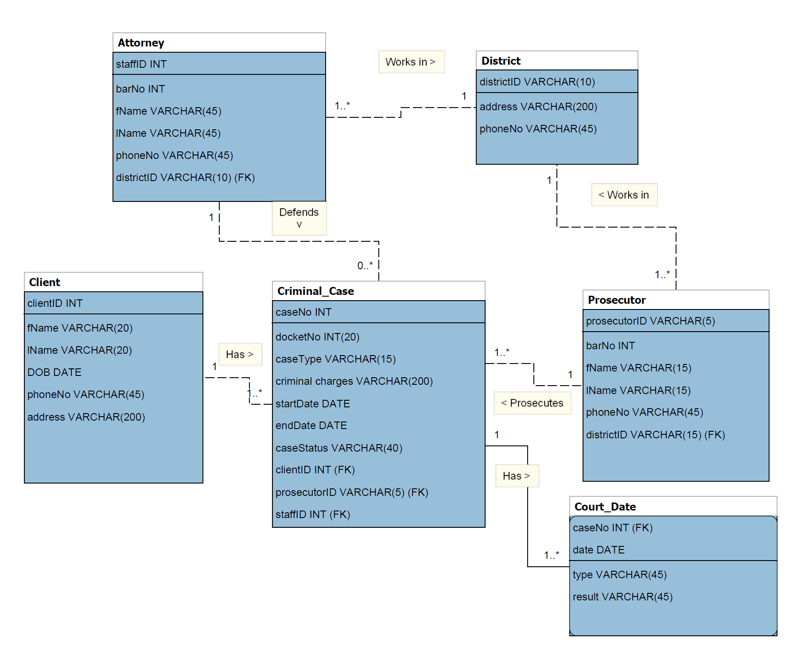

**Relational Model After Normalization**

**RELATIONS (primary key -> solid underline, foreign key -> dashed underline)**

**Attorney**(staffID, barNo, fName, lName, phoneNo, districtID)

**District**(districtID, address, phoneNo)

**Client**(clientID, fName, lName, DOB, phoneNo, address)

**Prosecutor**(prosecutorID, barNo, fName, lName, phoneNo, districtID)

**Criminal Case**(caseNo, docketNo, caseType, criminal charges, strtDate, endDate, caseStatus, clientID, prosecutorID, staffID, districtID)

**Court Date**(caseNo, date, type, result)

*note: caseNo is both a foreign key and part of the primary key

**DEPENDENCIES**

**Attorney**

staffID -> barNo, fName, lName, phoneNo, districtID

**District**

districtID -> address, phoneNo

**Client**

clientID -> fName, lName, DOB, phoneNo, address

**Prosecutor**

prosecutorID -> barNo, fName, lName, phoneNo, districtID

**Criminal Case**

caseNo -> docketNo, caseType, criminal charges, strtDate, endDate, caseStatus, clientID, prosecutorID, staffID, districtID

**Court Date**

caseNo, date -> type, result

**NORMAL FORM**

All the relations are in 3NF. They are in 3NF because they are in 2NF and no non-primary key attribute is transitively dependent on the primary key. They are in 2NF because every non-primary key attribute is fully functionally dependent on the primary key. They are in 1NF because the intersection of each row and column will contain one and only one value.

**Use Cases**

|  |  |  |  |
| --- | --- | --- | --- |
| **Use Case:** | **ENTER NEW ATTORNEY** | **ENTER NEW CLIENT** | **ENTER NEW CASE** |
| **Actor:** | **1st Defender, 2nd Defender** | **Attorney assigned to case** | **1st Defender, 2nd Defender, Attorney assigned to case** |
| **Steps:** | 1. Actor clicks on “New staff” button. 2. A new staff ID is shown. 3. Prompt to enter name, DOB, job title, salary, branch information 4. All information is displayed; ask for confirmation 5. User clicks on “Confirm” button | 1. Actor clicks on “New client” button. 2. New client ID is shown. 3. Prompt to enter name, DOB, address, phone, case number 4. All information is displayed; ask for confirmation 5. User clicks on “Confirm” button | 1. The actor clicks on “New case” button. 2. New caseNo is shown. 3. Prompt to docket number, charge, date charged, bond amount, if bonded, attorney assigned 4. All information is displayed; ask for confirmation 5. User clicks on “Confirm” button |
| **Use Case:** | **SEARCH/UPDATE CASE** | **SEARCH/UPDATE CLIENT** | **SEARCH/UPDATE BRANCH** |
| **Actor:** | **1st Defender, 2nd Defender, Attorney assigned to case** | **1st Defender, 2nd Defender, Attorney assigned to case** | **1st Defender** |
| **Steps:** | 1. The actor clicks “search cases” button. 2. Prompt to enter any of the attributes of case. 3. All search results are returned. 4. Actor clicks on desired search result to view instance. 5. All information is displayed. 6. Actors may update any field | 1. The actor clicks “search client” button. 2. Prompt to enter any of the attributes of client. 3. All search results are returned. 4. Actor clicks on desired search result to view instance. 5. All information is displayed. 6. Actors may update any field | 1. Actor clicks “search branches” button. 2. Prompt to enter branch no. 3. All instance information is displayed. 4. Actors may update any field |

**Use Cases cont’d**

|  |  |  |  |
| --- | --- | --- | --- |
| **Use Case:** | **SEARCH/UPDATE ATTORNEY** | **SEARCH/UPDATE DISTRICT** | **SEARCH PROSECUTOR** |
| **Actor:** | **1st Defender, 2nd Defender** | **1st Defender, 2nd Defender** | **1st Defender, 2nd Defender, IT, Attorneys.** |
| **Steps:** | 1. The actor clicks “search staff” button. 2. Prompt to enter any of the attributes of staff. 3. All search results are returned. 4. The actor clicks on the desired search result to view instance information. 5. All information is displayed. 6. Actors may update any field | 1. The actor clicks “search district” button. 2. Prompt to enter any of the attributes of district. 3. All search results are returned; 4. Actor clicks on desired search result to view instance information; 5. All information is displayed; 6. Actor may update any field | 1. The actor clicks “search prosecutor” button. 2. Prompt to enter any of the attributes of prosecutor. 3. All search results are returned; 4. Actor clicks on desired search result to view instance information; 5. All information is displayed; 6. Actor may update any field |
| **Use Case:** | **CREATE NEW TABLE** | **DELETE RECORDS/TABLES** | **UPDATE USER PROFILE/DATABASE FUNTIONALITIES** |
| **Actor:** | **IT Employees (Data Analyst)** | **IT Employees (Data Analyst)** | **IT Employees (Data Analyst)** |
| **Steps:** | 1. Actor clicks “Create Table” button. 2. Prompt to set table name. 3. Prompts to select no of columns. 4. Prompts to name and set data types for each column. 5. A new table is formed, and additional security steps can be implemented if needed | 1. Actor Clicks on Delete Records/Table button. 2. Prompt to specify which table/rows/column to delete 3. Specify which of the table/rows/column 4. Access is confirmed and request is granted if access is confirmed. 5. Record/table is then deleted | 1. The actor clicks on Advanced settings. 2. Click on update user profile. 3. Actor searches through the list of users in the database. 4. Prompt to enter the name of user to update. 5. All information is displayed. 6. Actor clicks on edit User. 7. update any field necessary and select submit 8. Profile is then updated. |

**Use Cases cont’d**

|  |  |  |  |
| --- | --- | --- | --- |
| **Use Case:** | **INSERT NEW PROSECUTOR** | **UPDATE PROSECUTOR** | **REMOVE/DELETE/PROSECUTOR** |
| **Actor:** | **Secretary to the 1st public defender** | **1st Public defender/2nd Public defender** | **IT Employees, Head of HR** |
| **Steps** | 1. The actor clicks on “New Prosecutor” button. 2. New Prosecutor ID is shown. 3. Prompt to enter name, DOB, address, phone, Bar number 4. All information is displayed; ask for confirmation 5. User clicks on “Confirm” button | 1. Actor clicks “search Prosecutor” button. 2. Prompt to enter any of the attributes of Prosecutor. 3. All search results are returned. 4. The actor clicks on desired search result to view instance. 5. All information is displayed. 6. Actor clicks on update record. 7. The actor Verifies credentials 8. Update is verified and updated if credential is authorized. | 1. Actor clicks “search Prosecutor” button. 2. Prompt to enter any of the attributes of Prosecutor. 3. All search results are returned. 4. Actor clicks on desired search result to view instance. 5. All information is displayed. 6. Actor selects Prosecutor record to delete. 7. The actor Verifies credentials 8. Deleted action is shown again so actor can be double certain about the action. 9. Credential is verified and Prosecutor record is deleted if credential is authorized. |

**Use Cases cont’d**

|  |  |  |  |
| --- | --- | --- | --- |
| **Use Case:** | **REMOVE/DELETE ATORNEY** | **REMOVE/DELETE DISTRICTS** | **REMOVE/DELETE CLIENTS** |
| **Actor:** | **1st Public defender/2nd Public defender** | **1st Public defender/2nd Public defender** | **Section chief/Assistant public defenders** |
| **Steps** | 1. Actor clicks “search Attorney” button. 2. Prompt to enter any of the attributes of Attorney. 3. All search results are returned. 4. The actor clicks on desired search result to view instance. 5. All information is displayed. 6. Actor selects Attorney record to delete. 7. The actor Verifies credentials 8. Deleted action is shown again so the actor can be double certain about the action. 9. Credential is verified and Attorney record is deleted if credential is authorized. | 1. Actor clicks “search District” button. 2. Prompt to enter any of the attributes of District. 3. All search results are returned. 4. The actor clicks on desired search result to view instance. 5. All information is displayed. 6. The actor selects District record to delete. 7. The actor Verifies credentials 8. Deleted action is shown again so actor can be double certain about the action. 9. Credential is verified and District record is deleted if credential is authorized. | 1. The actor clicks “search Client” button. 2. Prompt to enter any of the attributes of Client. 3. All search results are returned. 4. Actor clicks on the desired search result to view instance. 5. All information is displayed. 6. Actor selects Client record to delete. 7. The actor Verifies credentials 8. Deleted action is shown again so the actor can be double certain about the action. 9. Credential is verified and Client record is deleted if credential is authorized. |

**Use Cases cont’d**

|  |  |  |  |
| --- | --- | --- | --- |
| **Use Case** | **REMOVE/DELETE CASE** | **REMOVE/DELETE BRANCH** | **INSERT NEW DISTRICT** |
| **Actor:** | **Case administrator** | **1st Public defender/2nd Public defender** | **1st Public defender/2nd Public defender, Case administrator, Office administrator** |
| **Steps** | 1. The actor clicks “search cases” button. 2. Prompt to enter any of the attributes of Case. 3. All search results are returned. 4. Actor clicks on the desired search result to view instance. 5. All information is displayed. 6. Actor selects Case record to delete. 7. The actor Verifies credentials 8. Deleted action is shown again so the actor can be double certain about the action. 9. Credential is verified and case record is deleted if credential is authorized. | 1. The actor clicks “search Client” button. 2. Prompt to enter any of the attributes of Client. 3. All search results are returned. 4. The actor clicks on desired search result to view instance. 5. All information is displayed. 6. Actor selects Client record to delete. 7. Verify credentials 8. Deleted action is shown again so actor can be double certain about the action. 9. Credential is verified and Client record is deleted if credential is authorized. | 1. Actor clicks on “New District” button. 2. New District ID is shown. 3. Prompt to enter name, DOB, address, phone, Bar number 4. All information is displayed; ask for confirmation 5. User clicks on “Confirm” button |
| **Use Case:** | **INSERT/UPDATE COURT DATE** | **SEARCH COURT DATE** | **DELETE COURT DATE** |
| **Actor:** | **Case Administrator** | **Anyone with access to portal** | **Case administrator** |
| **Steps:** | 1. The actor clicks on “New Court Date” button. 2. Actor is asked to input case No 3. Once case No is authenticated, Actor is then asked to put new date and if new date is available per system requirement. 4. New Court date is then confirmed. | 1. The actor clicks “search Court date” button. 2. Prompt to enter any of range of date to search from. 3. All search results within the input range are returned. 4. Actor clicks on desired search date to view instance. 5. All information is displayed. | 1. The actor clicks “search Court date” button. 2. Actor is asked to input caseNo 3. Once caseNo is authenticated, the actor clicks on the option button and selects delete court date. 4. The actor Verifies credentials 5. The Delete action is shown again so the actor can be double certain about the action. 6. Credential is verified and Court date is deleted if credential is authorized. |

**Use Case Implementation (SQL statements)**

Attorney

**How many attorneys are employed by the 15th JDC Public Defenders Office? (aggregate):**

SELECT COUNT(staffID) AS attorneyCount

FROM Attorney;

**Insert new attorney staff (insert):**

INSERT INTO Attorney

VALUES (7, 661093383, 'Philip', 'Fry', '337-342-8894', 'D1');

**Remove attorney with staffID 4 (delete):**

DELETE FROM Attorney

WHERE staffID = 4

**Update BarNo for attorney with staffID 2 (update):**

UPDATE Attorney

SET barNo = 3455197

WHERE staffID = 2

**For all attorneys, list staffID, lname, fname, districtID, and district address; sorted by lname, fname (join Attorney/District):**

SELECT a.staffID, lName, fName, a.districtID, address

FROM Attorney a, District d

WHERE a.districtID = d.districtID

ORDER BY lname, fname;

**List docketNo and staffID for all cases belonging to attorney with staffID = 1 (join attorney/criminal case)**

SELECT docketNo, c.staffID

FROM criminal_case c, attorney a

WHERE c.staffID = a.staffID AND c.staffID = 1

**List docketNo, districtID, and address from all criminal cases (join criminal_case/district)**

District

**How many districts are covered by the 15th JDC PDO? (aggregate):**

SELECT COUNT(districtID) AS districtCount

FROM District;

**Insert new district (insert):**

INSERT INTO District

VALUES ('D4', '123 Congress Street, Lafayette, LA 70507', 33788900);

**Use Case Implementation (SQL statements) cont’d**

District cont’d

**Delete district with districtID D1 (delete):**

DELETE FROM District

WHERE districtID = 'D1';

**Update phoneNo for district with districtID D2 (update):**

UPDATE District

SET phoneNo = 3372230099

WHERE districtID = 'D2';

**List lName, fName, and districtID for all prosecutors that work in district with districtID D2 (join District/Prosecutor):**

SELECT lName, fName, p.districtID

FROM District d, Prosecutor p

WHERE p.districtID = 'D2' AND p.districtID = d.districtID;

Client

**How many clients does the 15th JDC PDO represent? (aggregate):**

SELECT COUNT(clientID) AS clientCount

FROM Client;

**Insert new client (insert):**

INSERT INTO Client

VALUES (20, 'Ryan', 'Sullivan', '1980-10-11', '337-333-3244', '123 Main St., Crowley, LA 76036')

**Delete client with clientID 1(delete):**

DELETE FROM Client

WHERE clientID = 1;

**Update phoneNo for client with clientID 2(update)**

UPDATE Client

SET phoneNo = 3378889388

WHERE clientID = 2;

**List ClientID, lName, fName, caseNo and docketNo for all cases belonging to client with clientID 1(join Client/Criminal case)**

SELECT b.clientID, lName, fName, caseNo, docketNo

FROM Client a, Criminal_Case b

WHERE b.clientID = 1 AND b.clientID = a.clientID;

**Use Case Implementation (SQL statements) cont’d**

Prosecutor

**How many prosecutors work in District with districtID D2?(aggregate):**

SELECT COUNT(ProsecutorID) AS prosecutorCount

FROM Prosecutor

WHERE districtID = 'D2';

**Insert new prosecutor (insert):**

INSERT INTO Prosecutor

VALUES ('A3', '33344409', 'James', 'Franco', '337-455-9909', 'D2');

**Delete prosecutor with prosecutorID 1 (delete):**

DELETE FROM Prosecutor

Where prosecutorID = 1;

**Update phoneNo for prosecutor with prosecutor ID 2(update)**

UPDATE Prosecutor

SET phoneNo = 3374445545

WHERE prosecutorID = 2;

**List lName, fName, districtID, and address for all Prosecutors, sorted by districtID (join prosecutor/district)**

SELECT lName, fName, d.districtID, address

FROM District d, Prosecutor p

WHERE d.districtID = p.districtID;

**List caseNo, client fName, client lName, prosecutorID, prosecutor fName and prosecutor lName for all cases (join prosecutor/criminal case)**

SELECT caseNo, docketNo, c.prosecutorID, p.fName, p.lName

FROM criminal_case c, prosecutor p

WHERE c.prosecutorID = p.prosecutorID;

Criminal_Case

**How many cases are assigned to the attorney with staffID 1? (aggregate)**

SELECT COUNT(caseNo) AS caseCount

FROM Criminal_Case

WHERE staffID = 1;

**Insert new criminal case (insert):**

INSERT INTO Criminal_Case (CaseNo, docketNo, caseType, `criminal charges` , startDate, caseStatus, clientID, prosecutorID, staffID)

VALUES (20, 2022236345, 'felony', 'Armed Robbery', '2022-04-21' , 'open', 2, 'A2', 3);

**Use Case Implementation (SQL statements) cont’d**

Criminal_Case cont’d

**Delete all closed cases (delete)**

DELETE FROM Criminal_Case

WHERE caseStatus = ‘closed’;

**Update endDate and caseStatus for Criminal Case with caseNo 11(update):**

UPDATE Criminal_Case

SET endDate = ‘2022-04-21’, caseStatus = ‘closed’;

WHERE caseNo = 11;

**List ClientID, lName, fName, caseNo, and docketNo for all cases belonging to client with ClientID 20 (join):**

SELECT a.clientID, lName, fName, caseNo, docketNo

FROM Criminal_Case a, Client b

WHERE a.clientID = 20 AND a.clientID = b.clientID;

**List clientID, docketNo and district for all cases belonging to client with ClientID 20 (join):**

SELECT clientID, docketNo, b.districtID

FROM Criminal_Case a, District b

WHERE clientID = 20 AND districtID = b.districtID

Court_date

**How many court dates has Criminal Case with caseNo 5(aggregate)?**

SELECT COUNT(date) AS courtDateCount

FROM Court_Date

WHERE caseNo = 1;

**Insert new future Court Date for Criminal Case with caseNo 2 (insert):**

INSERT INTO court_date (caseNo, date, type)

VALUES (2 , '2022-07-09', 'trial')

**Delete Court Date for caseNo 4, date ‘2022-07-09’ (delete):**

DELETE FROM Court Date

WHERE caseNo = 4 AND date = ‘2022-07-09’;

**Update Court date with caseNo 11, date ‘2022-04-21’ (update)**

UPDATE Court Date

SET result = ‘pled 8 yrs HL’

WHERE caseNo = 11 AND date = ‘2022-04-21’;

**Use Case Implementation (SQL statements) cont’d**

Court_date cont’d

**List caseNo, docketNo, date, type, and result for all Court Dates for caseNo 4 (join Criminal Case/Court Date):**

SELECT c.caseNo, docketNo, date, type, result

FROM Criminal_Case c, Court_Date d

WHERE c.caseNo = 4 AND c.caseNo = d.caseNo;

**Test Plan and Records**

**Attorney Entity**

1. **Insert new attorneys (insert)**

* **The Input:**

INSERT INTO attorney

VALUES

(1, 38593290, 'Robert', 'Johnson', '337-555-4356','D1'),

(2, 28591949, 'Samantha', 'Green', '337-555-3890','D1'),

(3, 886959403, 'Jack', 'Robertson', '337-250-9498','D2'),

(4, 74646477, 'Amy','Schoemer','337-250-9994','D2'),

(5, 38472222, 'Helen','Pierce','337-854-3324','D3'),

(6, 90009876,'Robert','Smith','337-854-3324','D3');

* **The Expected Output :**

|  |  |  |  |  |  |
| --- | --- | --- | --- | --- | --- |
| **StaffID** | **barNo** | **fName** | **lName** | **phoneNo** | **DistrictID** |
| 1 | 38593290 | Robert | Johnson | 337-555-4356 | D1 |
| 2 | 28591949 | Samantha | Green | 337-555-3890 | D1 |
| 3 | 886959403 | Jack | Robertson | 337-250-9498 | D2 |
| 4 | 74646477 | Amy | Schoemer | 337-250-9994 | D2 |
| 5 | 38472222 | Helen | Pierce | 337-854-2343 | D3 |
| 6 | 90009867 | Robert | Smith | 337-854-3324 | D3 |

* **The Actual Output :**

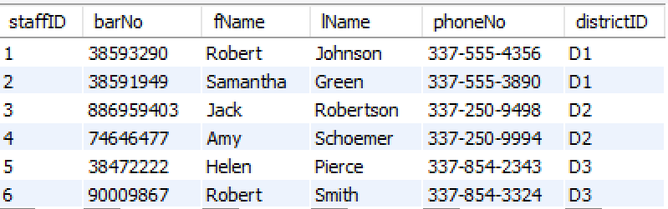

**Test Plan and Records cont’d**

1. **How many attorneys are employed by the 15th JDC Public Defenders Office? (aggregate):**

* **The Input:**

SELECT COUNT(staffID) AS attorneyCount

FROM Attorney;

* **The Expected Output :**

|  |
| --- |
| **attorneyCount** |
| 6 |

* **The Actual Output :**

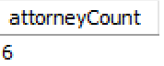

1. **Remove attorney with staffID 4 (delete)**

* **The Input:**

DELETE FROM Attorney

WHERE staffID = 4

* **The Expected Output :**

|  |  |  |  |  |  |
| --- | --- | --- | --- | --- | --- |
| **StaffID** | **barNo** | **fName** | **lName** | **phoneNo** | **DistrictID** |
| 1 | 38593290 | Robert | Johnson | 337-555-4356 | D1 |
| 2 | 28591949 | Samantha | Green | 337-555-3890 | D1 |
| 3 | 886959403 | Jack | Robertson | 337-250-9498 | D2 |
| 5 | 38472222 | Helen | Pierce | 337-854-2343 | D3 |
| 6 | 90009867 | Robert | Smith | 337-854-3324 | D3 |

* **The Actual Output :**

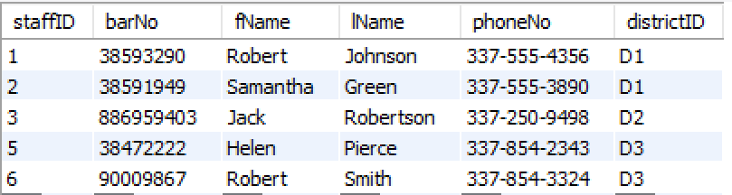

1. **Update BarNo for attorney with staffID 2 (update)**

* **The Input:**

UPDATE Attorney

SET barNo = 3455197

WHERE staffID = 2

**Test Plan and Records cont’d**

* **The Expected Output :**

|  |  |  |  |  |  |
| --- | --- | --- | --- | --- | --- |
| **StaffID** | **barNo** | **fName** | **lName** | **phoneNo** | **DistrictID** |
| 1 | 38593290 | Robert | Johnson | 337-555-4356 | D1 |
| 2 | 3455197 | Samantha | Green | 337-555-3890 | D1 |
| 3 | 886959403 | Jack | Robertson | 337-250-9498 | D2 |
| 5 | 38472222 | Helen | Pierce | 337-854-2343 | D3 |
| 6 | 90009867 | Robert | Smith | 337-854-3324 | D3 |

* **The Actual Output :**

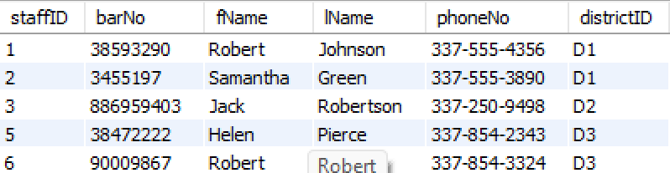

1. **For all attorneys, list staffID, lname, fname, districtID, and district address; sorted by lname, fname (join Attorney/District):**

* **The Input:**

SELECT a.staffID, lName, fName, a.districtID, address

FROM Attorney a, District d

WHERE a.districtID = d.districtID

ORDER BY lname, fname;

* **The Expected Output :**

|  |  |  |  |  |
| --- | --- | --- | --- | --- |
| **StaffID** | **lName** | **fName** | **districtID** | **address** |
| 2 | Green | Samantha | D1 | 800 S. Buchanan St., Lafayette, LA 70501 |
| 1 | Johnson | Robert | D1 | 800 S. Buchanan St., Lafayette, LA 70501 |
| 5 | Pierce | Helen | D3 | 100 North State St., Abeville, LA 70510 |
| 3 | Robertson | Jack | D2 | 500 N. Parkerson Ave., Crowley, LA 70527 |
| 6 | Smith | Robert | D3 | 100 North State St., Abeville, LA 70510 |

* **The Actual Output :**

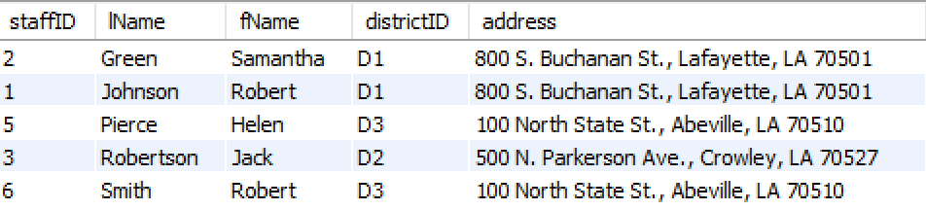

**Test Plan and Records cont’d**

1. **List docketNo and staffID for all cases belonging to attorney with staffID = 1 (join attorney/criminal case)**

* **The Input:**

SELECT docketNo, c.staffID

FROM criminal_case c, attorney a

WHERE c.staffID = a.staffID AND c.staffID = 1

* **The Expected Output :**

|  |  |
| --- | --- |
| **docketNo** | **staffID** |
| 202094567 | 1 |
| 202244432 | 1 |

* **The Actual Output :**

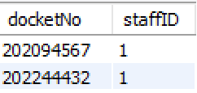

**District Entity**

1. **Insert new district (insert):**

* **The Input:**

INSERT INTO district

VALUES

('D1', '800 S. Buchanan St., Lafayette, LA 70501', '337-291-6400'),

('D2', '500 N. Parkerson Ave., Crowley, LA 70527', '337-788-8881'),

('D3', '100 North State St., Abeville, LA 70510', '337-898-1992')

('D4', '0 North State St., Aleville, LA 70510', '337-898-1992');

* **The Expected Output :**

|  |  |  |
| --- | --- | --- |
| **districtID** | **address** | **phoneNo** |
| D1 | 800 S. Buchanan St., Lafayette, LA 70501 | 337-291-6400 |
| D2 | 500 N. Parkerson Ave., Crowley, LA 70527 | 337-788-8881 |
| D3 | 100 North State St., Abeville, LA 70510 | 337-898-1992 |
| D4 | 0 North State St., Alevile, LA 70510 | 337-898-1992 |

* **The Actual Output :**

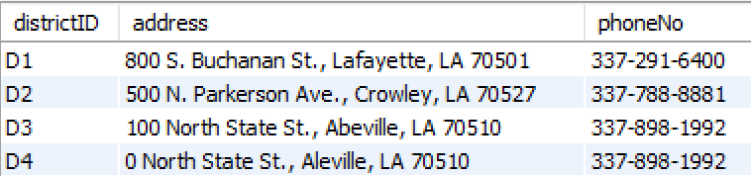

**Test Plan and Records cont’d**

1. **How many districts are covered by the 15th JDC PDO? (aggregate):**

* **The Input:**

SELECT COUNT(districtID) AS districtCount

FROM District;

* **The Expected Output :**

|  |
| --- |
| **districtCount** |
| 4 |

* **The Actual Output :**

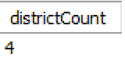

1. **Delete district with districtID D1 (delete):**

* **The Input:**

DELETE FROM District

WHERE districtID = 'D4';

* **The Expected Output :**

|  |  |  |
| --- | --- | --- |
| **districtID** | **address** | **phoneNo** |
| D1 | 800 S. Buchanan St., Lafayette, LA 70501 | 337-291-6400 |
| D2 | 500 N. Parkerson Ave., Crowley, LA 70527 | 337-788-8881 |
| D3 | 100 North State St., Abeville, LA 70510 | 337-898-1992 |

* **The Actual Output :**

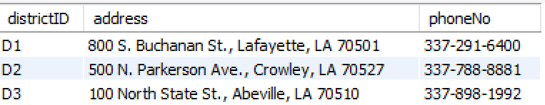

1. **Update phoneNo for district with districtID D2 (update):**

* **The Input:**

UPDATE District

SET phoneNo = '337-223-0099'

WHERE districtID = 'D2';

* **The Expected Output :**

|  |  |  |
| --- | --- | --- |
| **districtID** | **address** | **phoneNo** |
| D1 | 800 S. Buchanan St., Lafayette, LA 70501 | 337-291-6400 |
| D2 | 500 N. Parkerson Ave., Crowley, LA 70527 | 337-223-0099 |
| D3 | 100 North State St., Abeville, LA 70510 | 337-898-1992 |

**Test Plan and Records cont’d**

* **The Actual Output :**

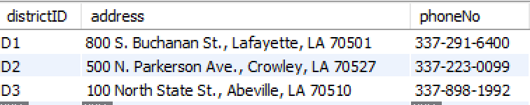

1. **List lName, fName, and districtID for all prosecutors that work in district with districtID D2 (join District/Prosecutor):**

* **The Input:**

SELECT lName, fName, p.districtID

FROM District d, Prosecutor p

WHERE p.districtID = 'D2' AND p.districtID = d.districtID;

* **The Expected Output :**

|  |  |  |
| --- | --- | --- |
| **lName** | **fName** | **DistrictID** |
| Peterson | Sam | D2 |
| Jackson | Peter | D2 |
| Franco | James | D2 |

* **The Actual Output :**

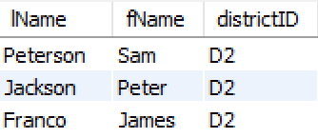

**Client Entity**

1. **Insert new clients (insert):**

* **The Input :**

INSERT INTO Client

VALUES

('10', 'Ryann', 'Sullivann', DATE '1981-10-11', '33733732', '122 Main St., Crowley, LA 76036'),

('20', 'Stive', 'Bolt', DATE '1989-10-10', '33744332', '121 Main St., Crowley, NM 76036'),

('30', 'John', 'Brown', DATE '1983-10-7', '33733355', '4723 Green St., Houston, TX 77044'),

('40', 'Adam', 'Downson', DATE '1986-10-1', '33733365', '123 Valley St., Dallas, TX 79054'),

('50', 'Oscar', 'Templeton', DATE '1984-5-22', '33733326', '123 Ginosa St., Austin, TX 70022');

* **The Expected Output :**

|  |  |  |  |  |  |
| --- | --- | --- | --- | --- | --- |
| **clientID** | **fName** | **lName** | **DOB** | **phoneNo** | **address** |
| **10** | Ryann | Sullivann | 1981-10-11 | 33733732 | 122 Main St., Crowley, LA 76036 |
| **20** | Stive | Bolt | 1989-10-10 | 33744332 | 121 Main St., Crowley, NM 76036 |
| **30** | John | Brown | 1983-10-7 | 33733355 | 4723 Green St., Houston, TX 77044 |
| **40** | Adam | Downson | 1986-10-1 | 33733365 | 123 Valley St., Dallas, TX 79054 |
| **50** | Oscar | Templeton | 1984-5-22 | 33733326 | 123 Ginosa St., Austin, TX 70022 |

* 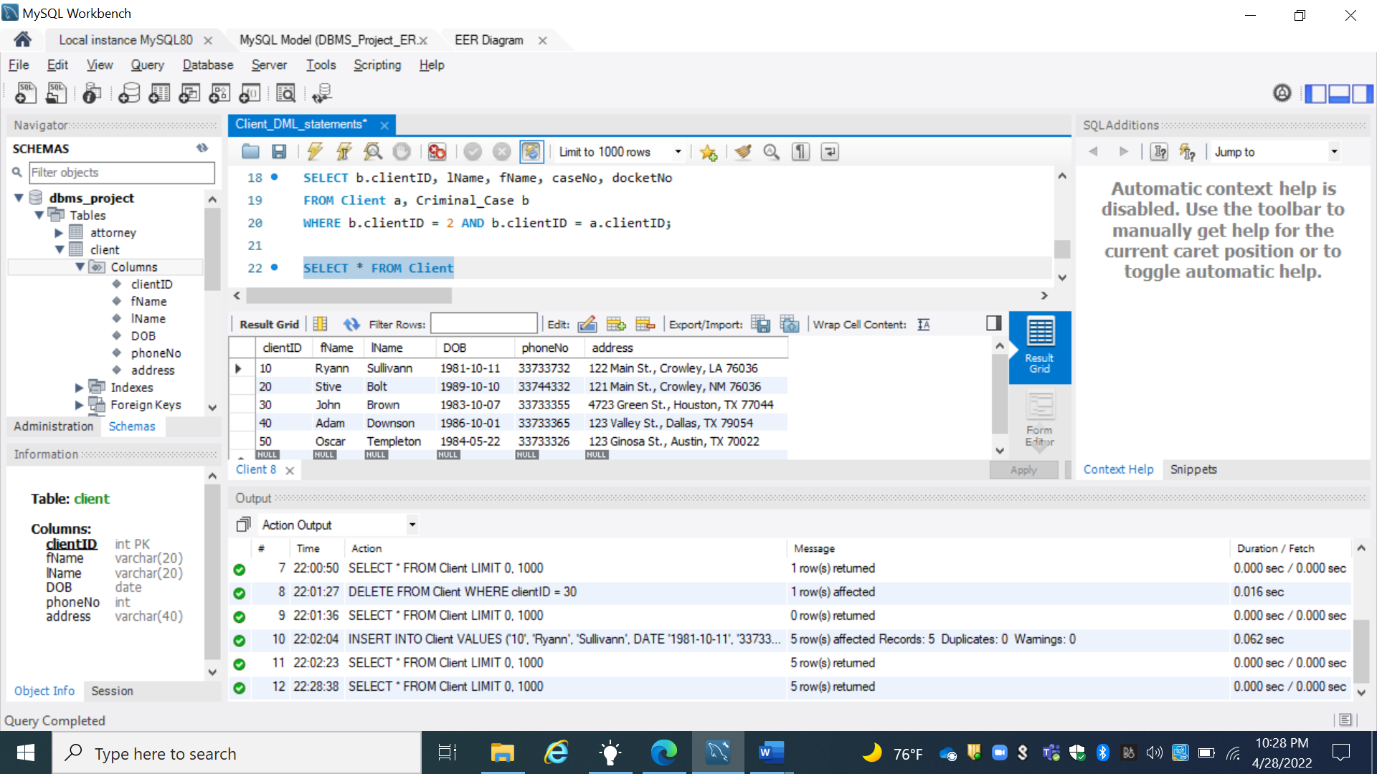**The Actual Output :**

1. **How many clients does the 15th JDC PDO represent? (aggregate):**

* **The Input :**

SELECT COUNT (clientID) AS clientCount

FROM Client;

* **The Expected Output :**

|  |
| --- |
| **clientCount** |
| **5** |

**The Actual Output :**

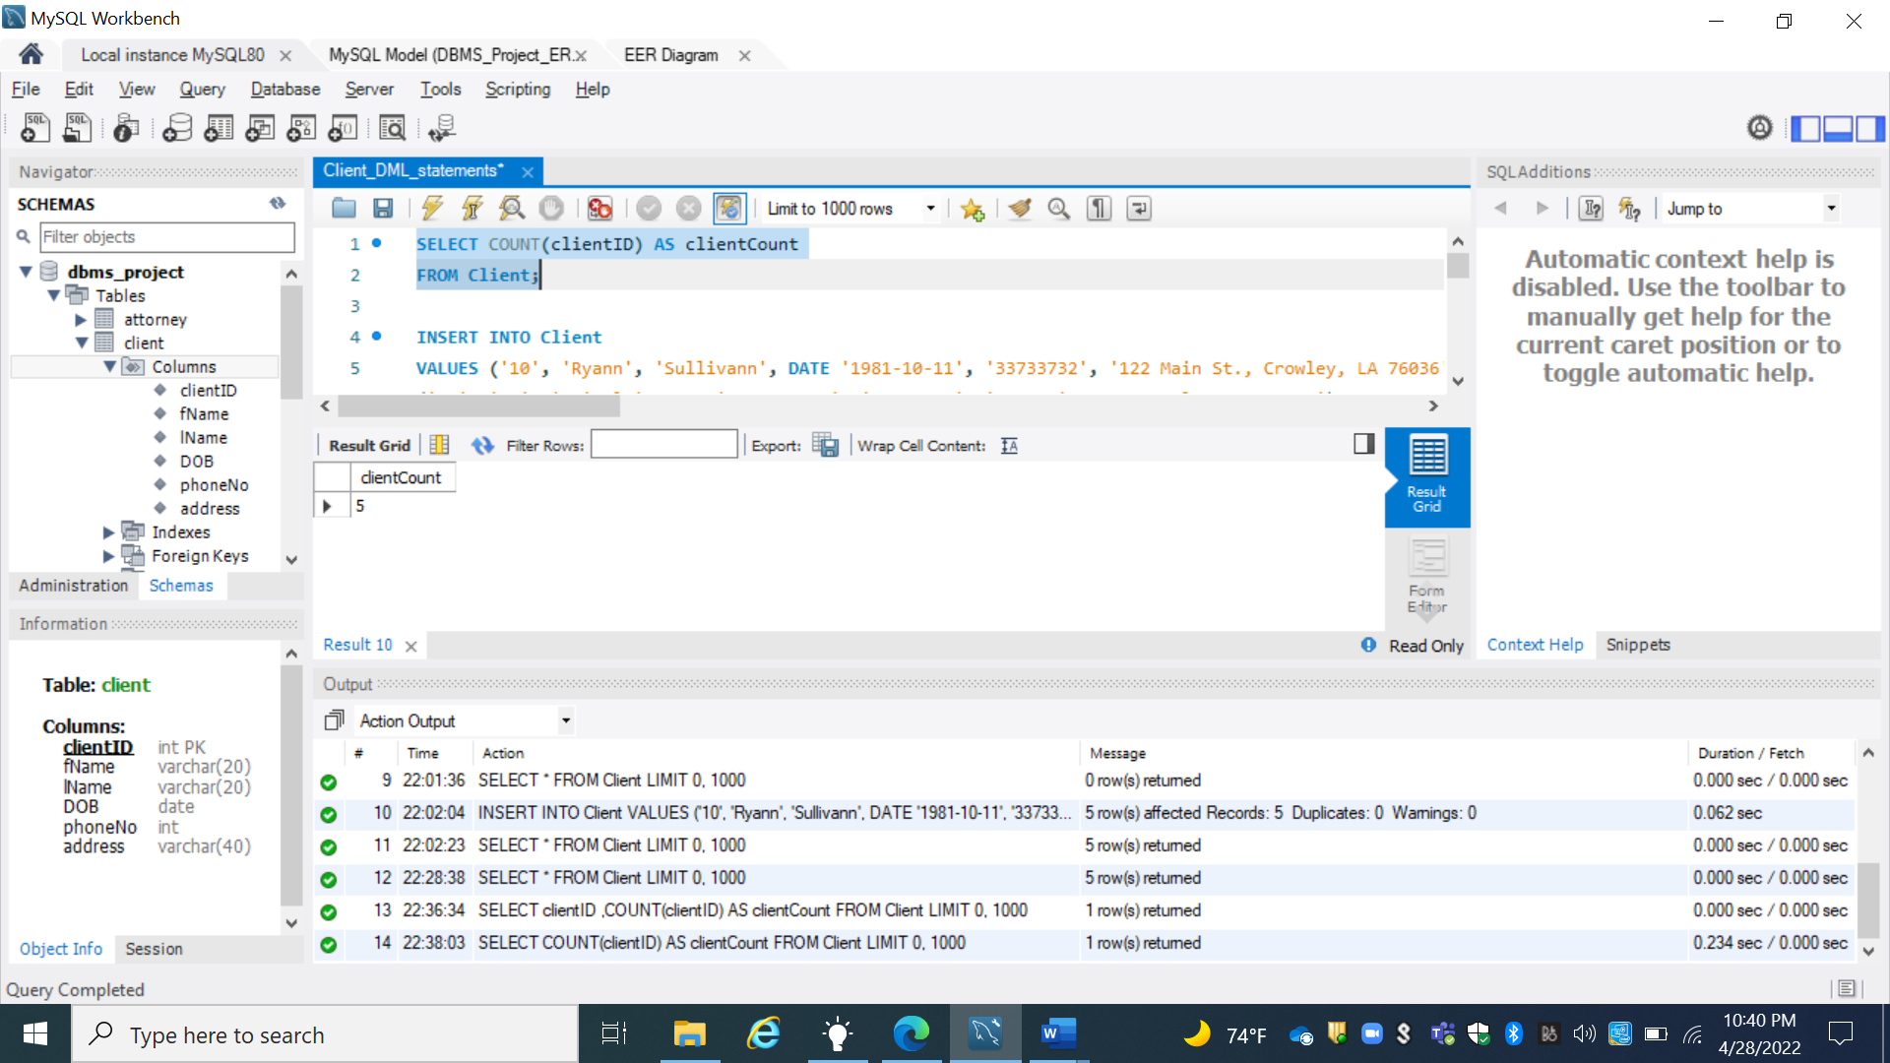

1. **Delete client with clientID 1(delete):**

* **The Input :**

DELETE FROM Client

WHERE clientID = 40;

* **The Expected Output :**

|  |  |  |  |  |  |
| --- | --- | --- | --- | --- | --- |
| **clientID** | **fName** | **lName** | **DOB** | **phoneNo** | **address** |
| **10** | Ryann | Sullivann | 1981-10-11 | 33733732 | 122 Main St., Crowley, LA 76036 |
| **20** | Stive | Bolt | 1989-10-10 | 33744332 | 121 Main St., Crowley, NM 76036 |
| **30** | John | Brown | 1983-10-7 | 33733355 | 4723 Green St., Houston, TX 77044 |
| **50** | Oscar | Templeton | 1984-5-22 | 33733326 | 123 Ginosa St., Austin, TX 70022 |

* **The Actual Output :**

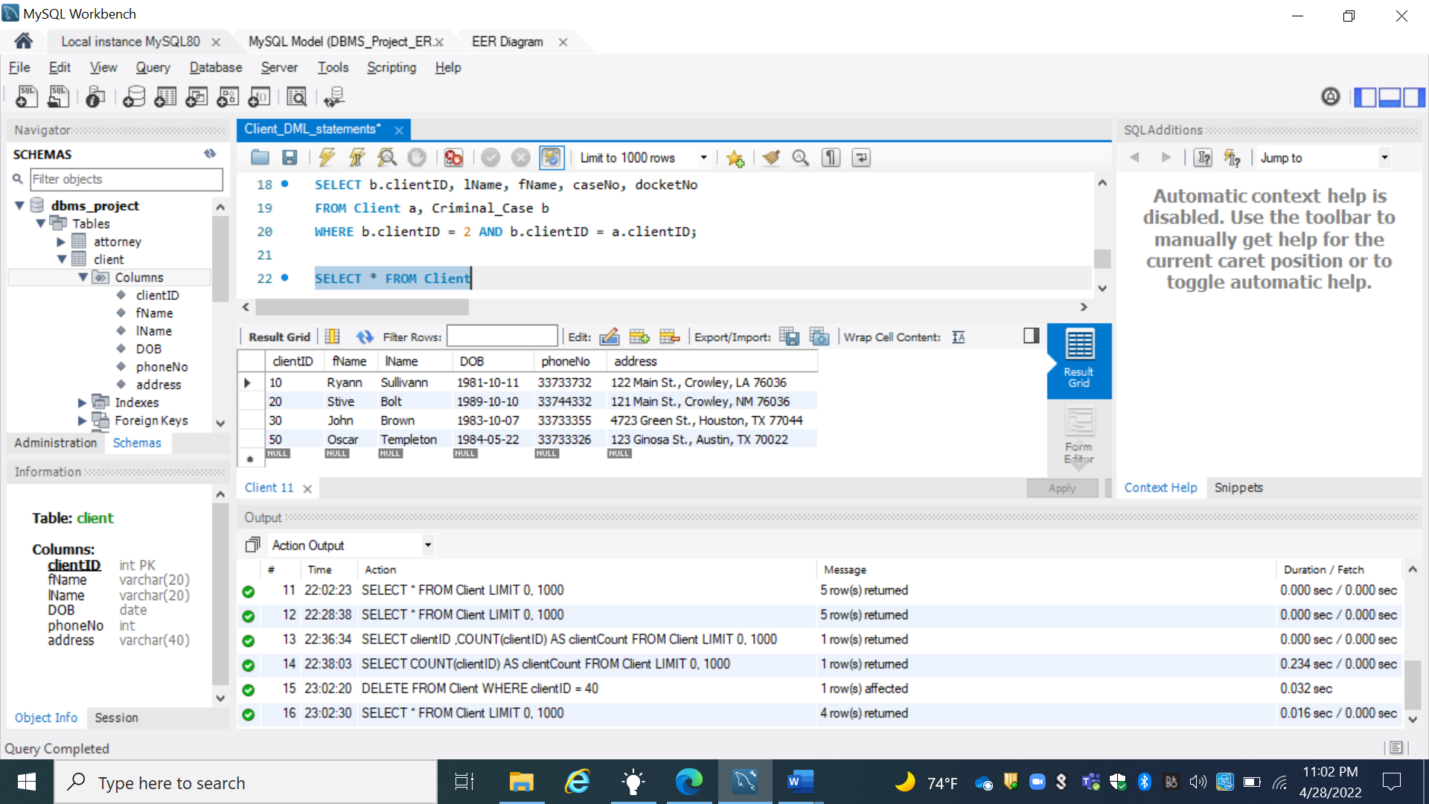

1. **Update phoneNo for client with clientID 2(update)**

* **The Input :**

UPDATE Client

SET phoneNo = 33788890

WHERE clientID = 20;

* **The expected Output :**

|  |  |  |  |  |  |
| --- | --- | --- | --- | --- | --- |
| **clientID** | **fName** | **lName** | **DOB** | **phoneNo** | **address** |
| **10** | Ryann | Sullivann | 1981-10-11 | 33733732 | 122 Main St., Crowley, LA 76036 |
| **20** | Stive | Bolt | 1989-10-10 | 33788890 | 121 Main St., Crowley, NM 76036 |
| **30** | John | Brown | 1983-10-7 | 33733355 | 4723 Green St., Houston, TX 77044 |
| **50** | Oscar | Templeton | 1984-5-22 | 33733326 | 123 Ginosa St., Austin, TX 70022 |

* **The Actual Output :**

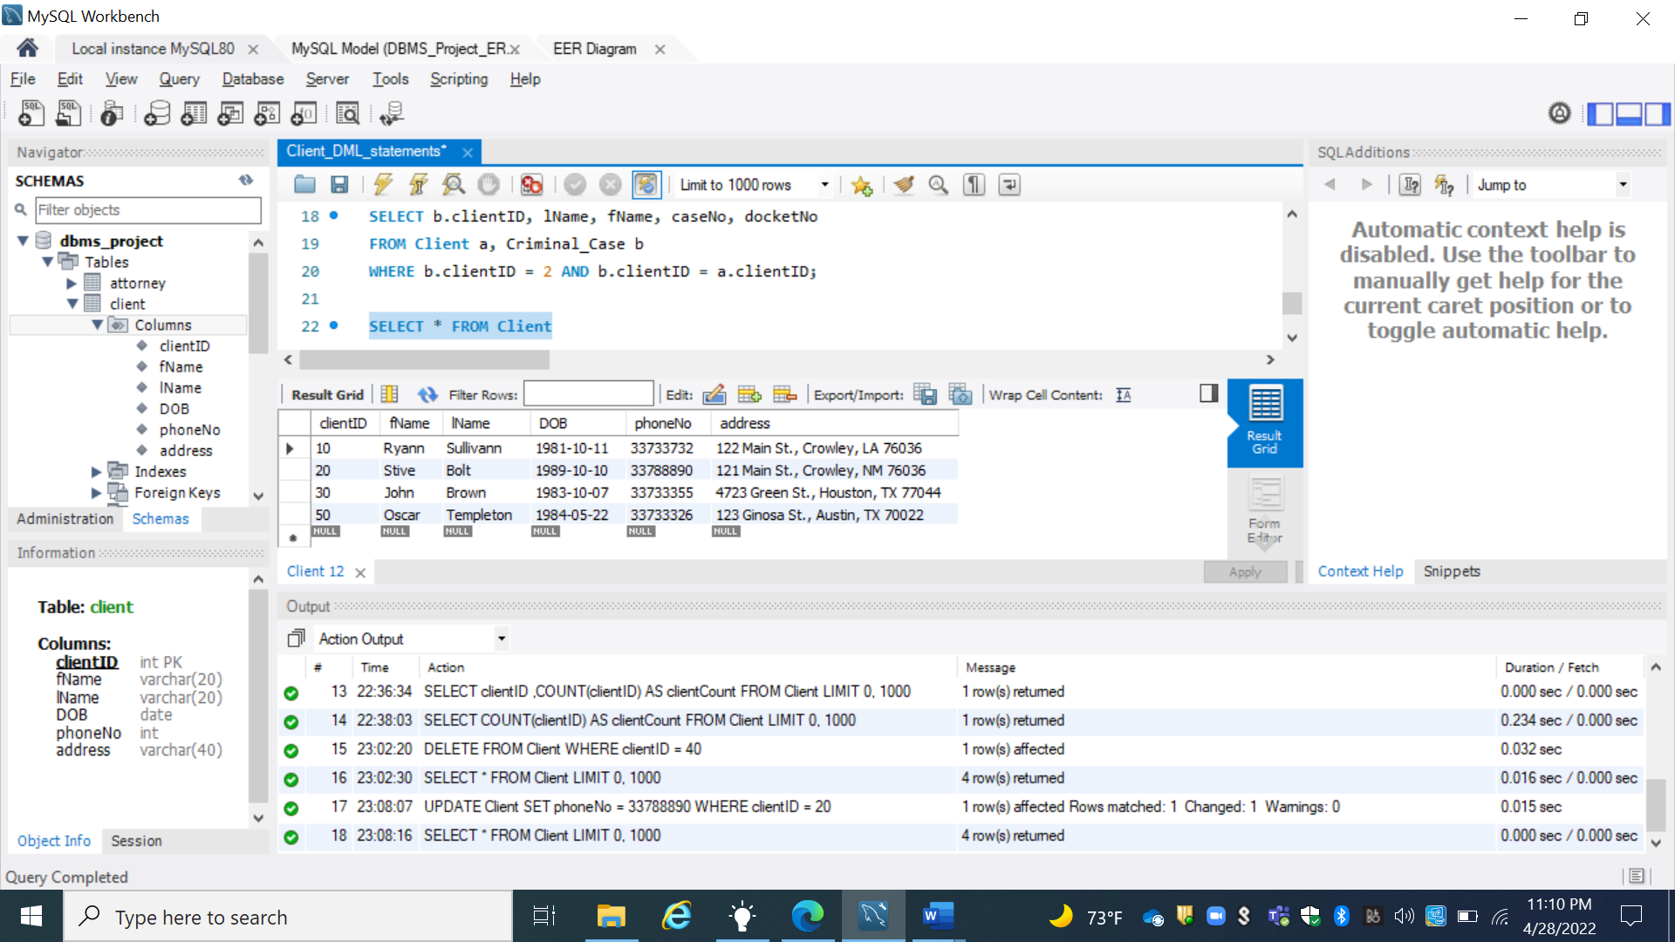

1. **List ClientID, lName, fName, caseNo and docketNo for all cases belonging to client with clientID 2 (join Client/Criminal case)**

* **The Input :**

SELECT b.clientID, lName, fName, caseNo, docketNo

FROM Client a, Criminal_Case b

WHERE b.clientID = 20 AND b.clientID = a.clientID;

* **The Expected Output :**

|  |  |  |  |  |
| --- | --- | --- | --- | --- |
| clientID | lName | fName | caseNo | docketNo |
| 20 | Bolt | Stive | 20 | 23345 |

* **The Actual Output :**

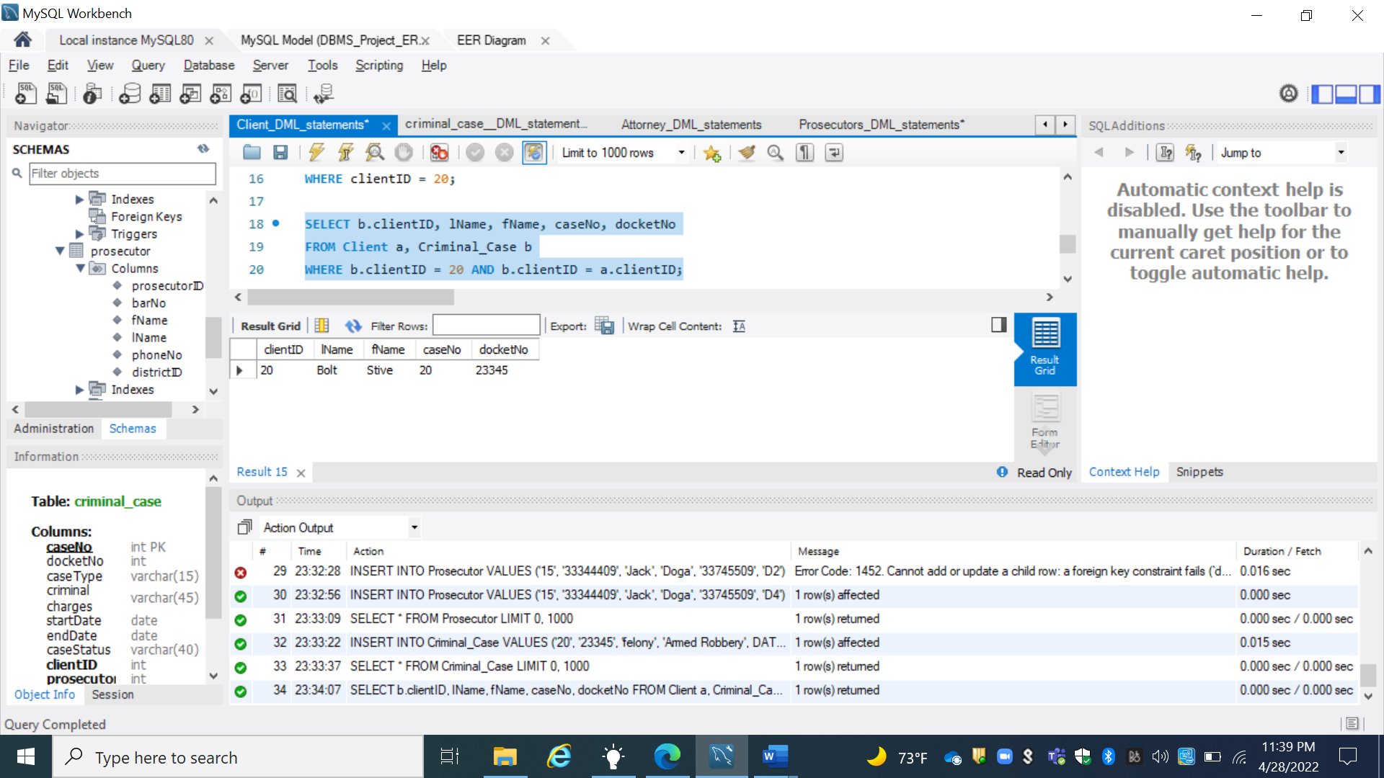

**Prosecutor Entity**

1. **Insert new prosecutor (insert)**

* **The Input :**

INSERT INTO Prosecutor

VALUES

('15', '33344409', 'Jack', 'Doga', '33745509', 'D4'),

('16', '33344410', 'Danny', 'Doglas', '33745511', 'D5'),

('17', '33344411', 'Robert', 'Albert', '33745573', 'D6'),

('18', '33344412', 'Jason', 'Thomas', '33745577', 'D6'),

('19', '33344413', 'Peter', 'Rodrigo', '33745500', 'D8');

* **The Expected Output**

|  |  |  |  |  |  |
| --- | --- | --- | --- | --- | --- |
| **prosecutorID** | **barNo** | **fName** | **lName** | **phoneNo** | **districtID** |
| 15 | 33344409 | Jack | Doga | 33745509 | D4 |
| **16** | 33344410 | Danny | Doglas | 33745511 | D5 |
| **17** | 33344411 | Robert | Albert | 33745573 | D6 |
| **18** | 33344412 | Jason | Thomas | 33745577 | D7 |
| **19** | 33344413 | Peter | Rodrigo | 33745500 | D8 |

* **The Actual Output**

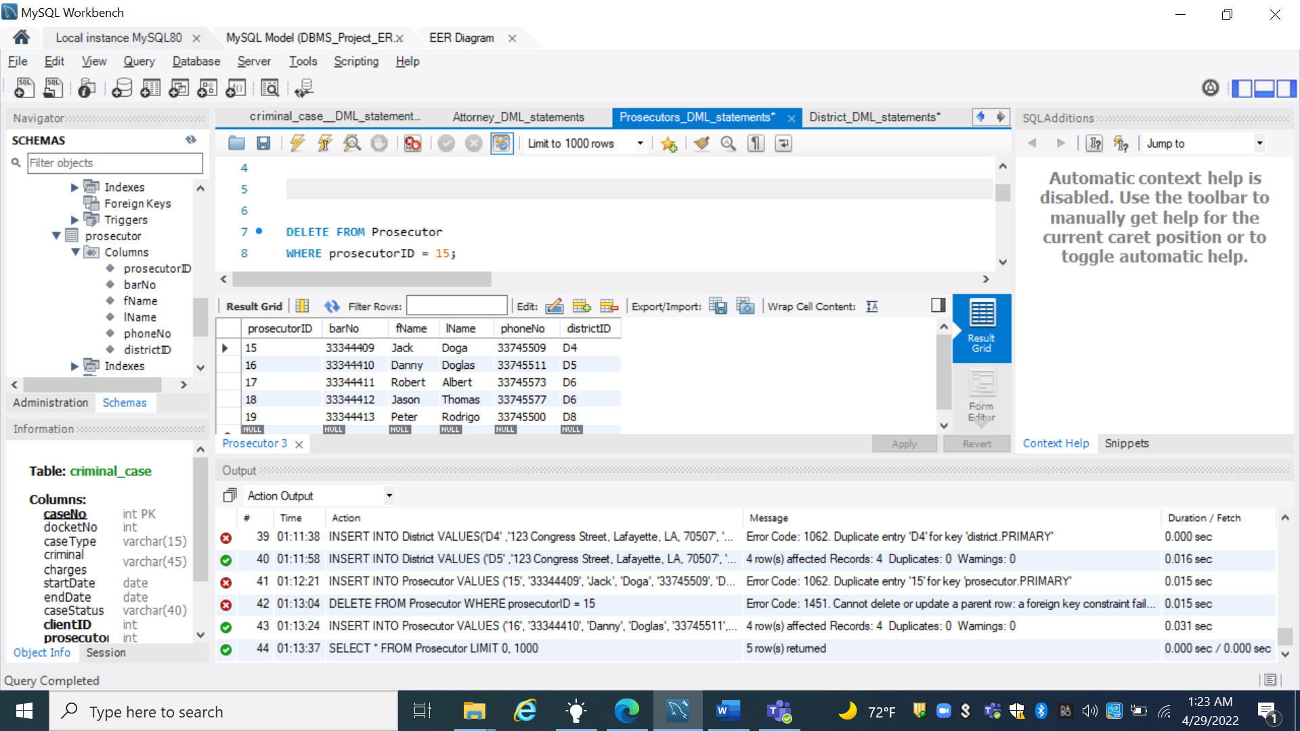

1. **How many prosecutors work in District with districtID D2 ? (aggregate)**

* **The Input :**

SELECT COUNT(ProsecutorID) AS prosecutorCount

FROM Prosecutor

WHERE districtID = 'D4';

* **The Expected Output :**

|  |
| --- |
| **proscutorCount** |
| **1** |

* **The Actual Output :**

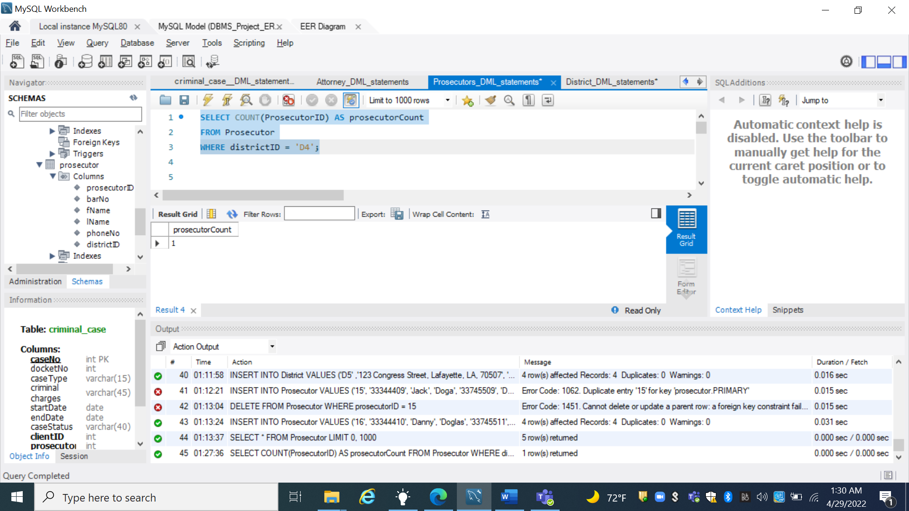

1. **Delete prosecutor with prosecutorID 1 (delete)**

* **The Input :**

DELETE FROM Prosecutor

WHERE prosecutorID = 16;

* **The Expected Output :**

|  |  |  |  |  |  |
| --- | --- | --- | --- | --- | --- |
| **prosecutorID** | **barNo** | **fName** | **lName** | **phoneNo** | **districtID** |
| 15 | 33344409 | Jack | Doga | 33745509 | D4 |
| **17** | 33344411 | Robert | Albert | 33745573 | D6 |
| **18** | 33344412 | Jason | Thomas | 33745577 | D7 |
| **19** | 33344413 | Peter | Rodrigo | 33745500 | D8 |

* **The Actual Output :**

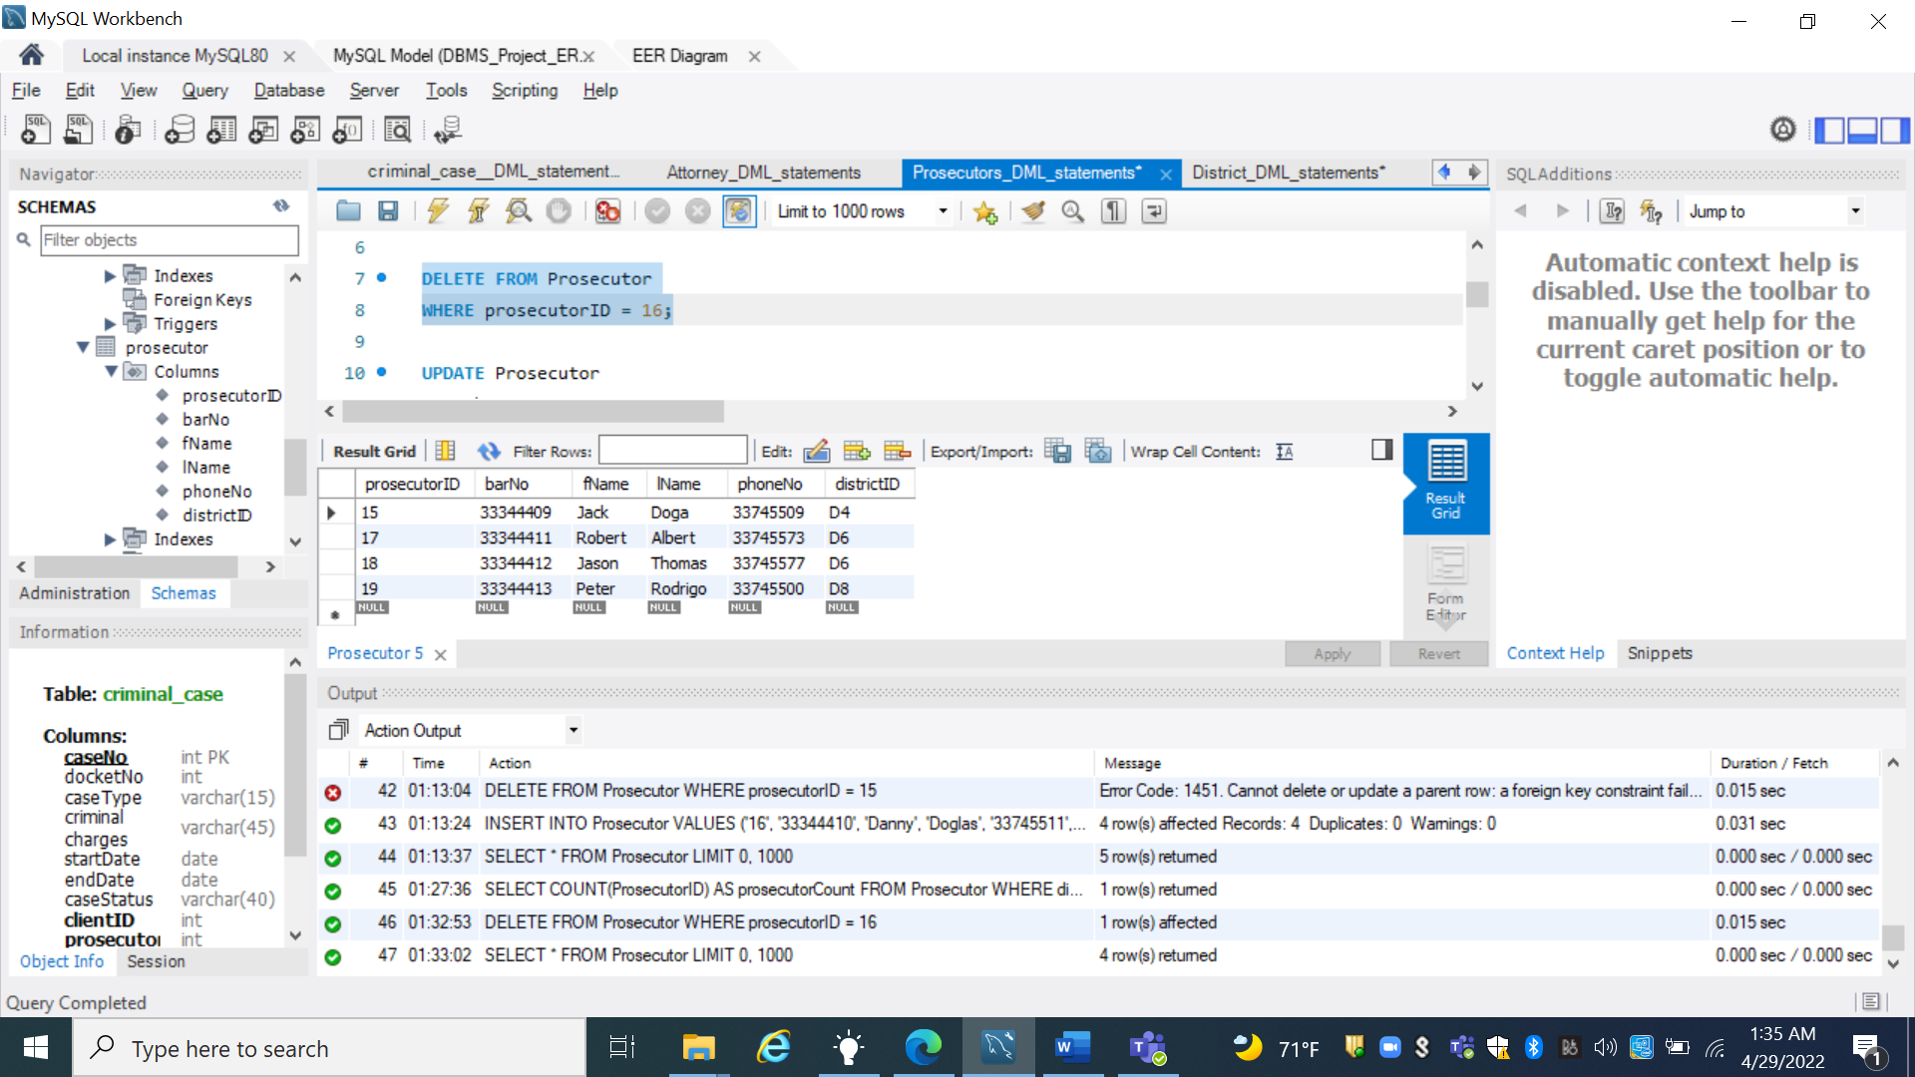

1. **Update phoneNo for prosecutor with prosecutor ID 2(update)**

* **The Input :**

UPDATE Prosecutor

SET phoneNo = 33744455

WHERE prosecutorID = 17;

* **The Expected Output :**

|  |  |  |  |  |  |
| --- | --- | --- | --- | --- | --- |
| **prosecutorID** | **barNo** | **fName** | **lName** | **phoneNo** | **districtID** |
| 15 | 33344409 | Jack | Doga | 33745509 | D4 |
| **17** | 33344411 | Robert | Albert | 33744455 | D6 |
| **18** | 33344412 | Jason | Thomas | 33745577 | D7 |
| **19** | 33344413 | Peter | Rodrigo | 33745500 | D8 |

* **The Actual Output :**

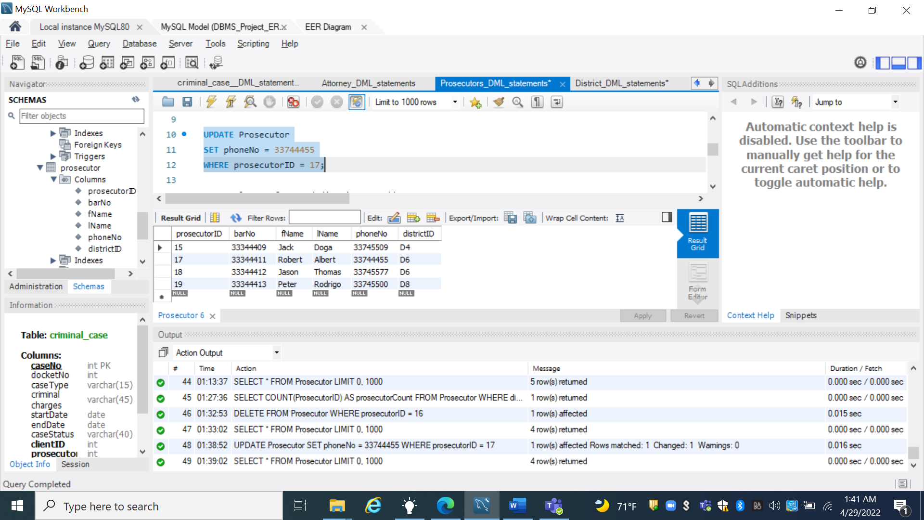

1. **List lName, fName, districtID, and address for all Prosecutors, sorted by districtID (join)**

* **The Input :**

SELECT lName, fName, d.districtID, address

FROM District d, Prosecutor p

WHERE d.districtID = p.districtID;

* **The Expected Output :**

|  |  |  |  |
| --- | --- | --- | --- |
| lName | fName | districtID | address |
| Doga | Jack | D4 | 123 Congress Street, Lafayette, LA, 70507 |
| Albert | Robert | D6 | 222 Main Street, Lafayette, LA, 70563 |
| Thomas | Jason | D7 | 244 Felona St, Lafayette, LA, 70500 |
| Rodrigo | Peter | D8 | 111 Rosa STt, Lafayette, LA, 70511 |

* **The Actual Output :**

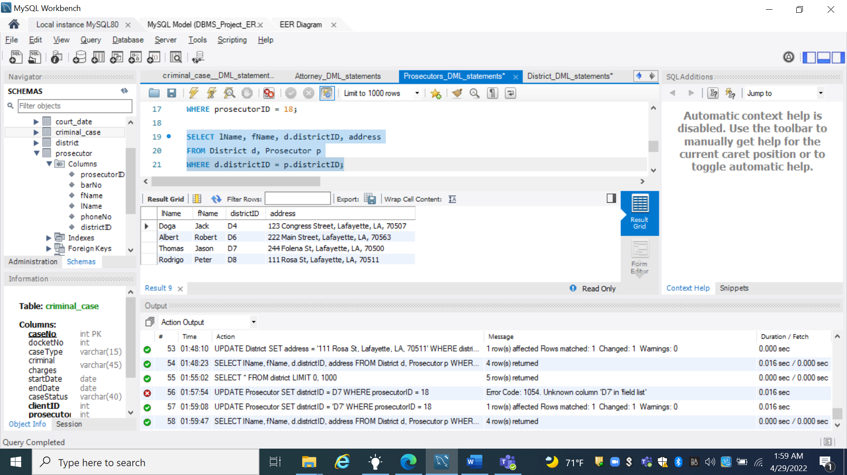

**CRIMINAL_CASE ENTITY**

1. **Insert new Criminal Case (insert)**

* **The Input :**

INSERT INTO criminal_case

VALUES

('1', '0001', 'felony', 'Armed Robbery', '2022-04-21', '2022-08-12', 'open', '2', '012', '3'),

('2', '0002', 'misdemeanor', 'shoplifting', '2022-01-15' , '2022-09-02', 'open', '4', '111', '3'),

('3', '0003', 'felony', 'Attempted murder', '2022-03-02' , '2022-04-17', 'closed', '6', '115', '1'),

('4', '0004', 'misdemeanor', 'petty theft', '2022-04-13' ,'2022-05-15', 'open', '12', '116', '5'),

('5', '0005', 'felony', 'Aggrevated assault', '2021-08-19' ,'2021-12-17', 'closed', '8', '115', '2'),

('6', '0006', 'misdemeanor', 'simple assault', '2021-05-12' ,'2022-05-29', 'open', '22', '007', '1');

* **The Expected Output :**
* **The Actual Output :**

**How many cases are assigned to the attorney with staffID 1? (aggregate)**

SELECT COUNT(caseNo) AS caseCount

FROM Criminal_Case

WHERE staffID = 1;

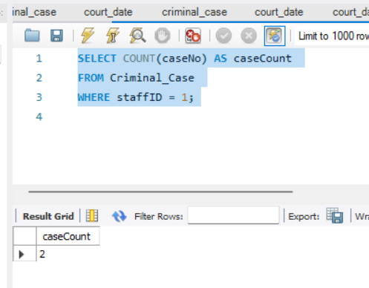

**Insert new criminal case (insert):**

INSERT INTO Criminal_Case (CaseNo, docketNo, caseType, `criminal charges` , startDate, caseStatus, clientID, prosecutorID, staffID)

VALUES (20, 2022236345, 'felony', 'Armed Robbery', '2022-04-21' , 'open', 2, '112', 3);

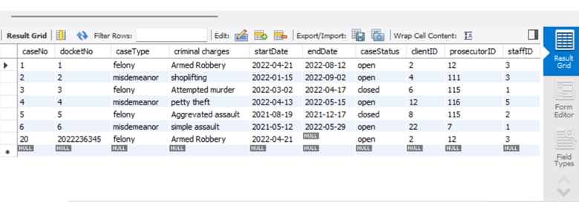

**Delete all closed cases (delete)**

DELETE FROM Criminal_Case

WHERE caseStatus = ‘closed’;

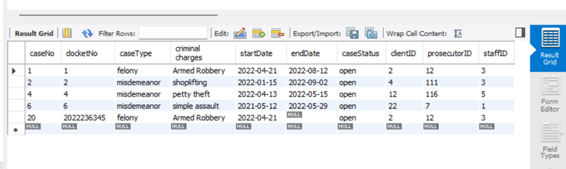

**List ClientID, lName, fName, caseNo, and docketNo for all cases belonging to client with ClientID 20 (join):**

SELECT a.clientID, lName, fName, caseNo, docketNo

FROM Criminal_Case a, Client b

WHERE a.clientID = 20 AND a.clientID = b.clientID;

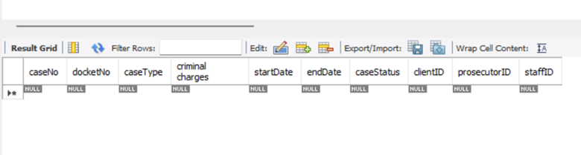

**Update endDate and caseStatus for Criminal Case with caseNo 11(update):**

UPDATE Criminal_Case

SET endDate = ‘2022-03-21’, caseStatus = ‘closed’;

WHERE caseNo = 4;

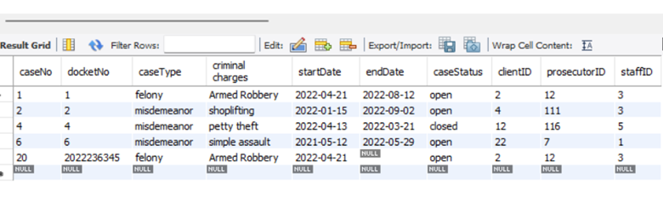

**COURT DATE**

INSERT INTO court_date (caseNo, date, type)

VALUES (1 , '2021-04-09', 'trial')

VALUES (2 , '2022-09-09', 'trial')

VALUES (3 , '2022-01-15', 'trial')

VALUES (4 , '2022-07-09', 'trial')

VALUES (5 , '2022-12-05', 'trial')

VALUES (11 , '2022-07-09', 'trial')

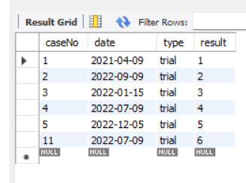

**How many court dates has Criminal Case with caseNo 5(aggregate)?**

SELECT COUNT(date) AS courtDateCount

FROM Court_Date

WHERE caseNo = 1;

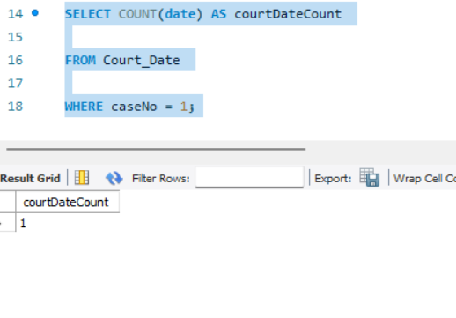

**Insert new future Court Date for Criminal Case with caseNo 2 (insert):**

INSERT INTO court_date (caseNo, date, type)

VALUES (2 , '2022-07-09', 'trial')

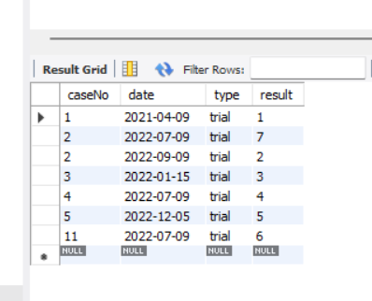

**List caseNo, docketNo, date, type, and result for all Court Dates for caseNo 4 (join Criminal Case/Court Date):**

SELECT c.caseNo, docketNo, date, type, result

FROM Criminal_Case c, Court_Date d

WHERE c.caseNo = 4 AND c.caseNo = d.caseNo;

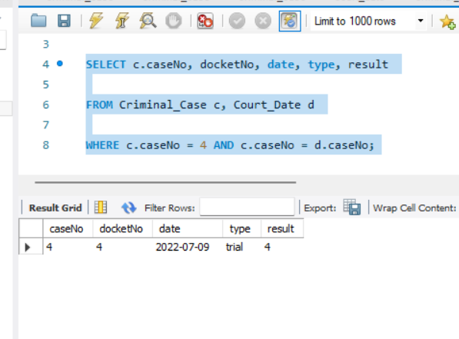

**Update Court date with caseNo 11, date ‘2022-04-21’ (update)**

UPDATE Court Date

SET result = ‘pled eight yrs HL’

WHERE caseNo = 11 AND date = ‘2022-07-21’;

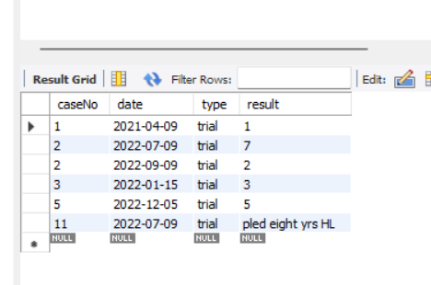

**Delete Court Date for caseNo 4, date ‘2022-07-09’ (delete):**

DELETE FROM Court Date

WHERE caseNo = 4 AND date = ‘2022-07-09’;

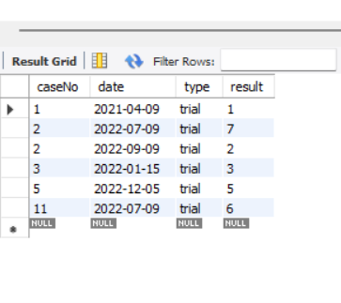

**Conclusion**

The presented DBMS was in the purpose of building a robust DBMS for Public Defenders System. So, in order to achieve that, first of all we had very well determined the mission statement and objectives to define the major aims of the DB system via the experience in the domain of our colleague Erwin Kristel. Then we went throughout all the conceptional and relational modeling tasks to build a strong normalized relational model to prevent some relationship contradictions in further steps. Once we had our physical model ready, we had implemented all our use cases including the SQL statements for every use case. Finally, we ran tests for our statements using simulated data by specifying the input statement, the expected output and the actual output. All tests outputs came out as expected.